**Population Trending and other Correlating Factors.**

From a naive perspective, one would assume that the trending of unnatural deaths should match the trending of population growth i.e. the death rates should directly tie into the population growth rate as illustrated in the graph below [Note: all graphs have Total (blue), Male (orange) and Female (green) values.

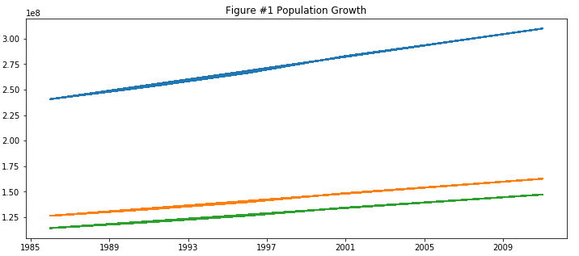

However, there are factors that one would need to consider that would ultimately affect the death rate such as geo-political, environmental, economical, etc. and that could also create anomalies in the population growth. When using total international death as the total death trending, one can see the trending is more erratic than the population trending.

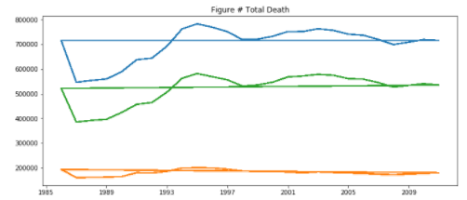

Unnatural Deaths by Type:

*When aggregated, Transportation incidents have an overall downward slope even though the population is trending upwards. This is contrary to our initial suggestion of naive correlation.*

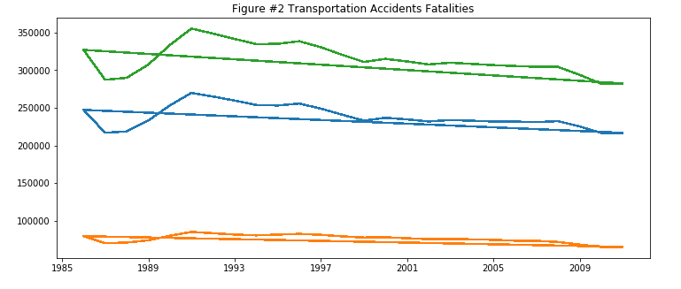

*Incidents involving falls have an upwards slope but have more volatility than population growth.*

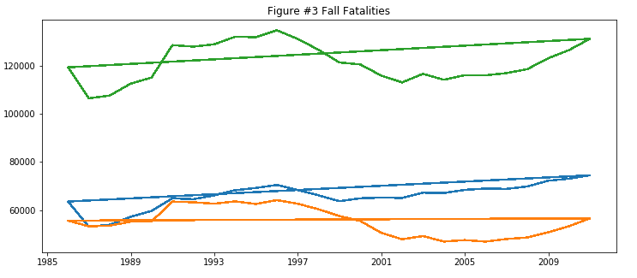

*Drowning Fatalities are on a decline as well, which is divergent to the population growth.*

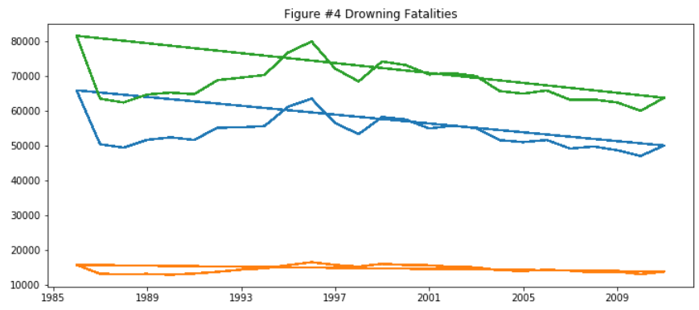

*Assault Incidents follow a similar trend as the population growth. This shows more of a correlated relationship between Assaults and Population.*

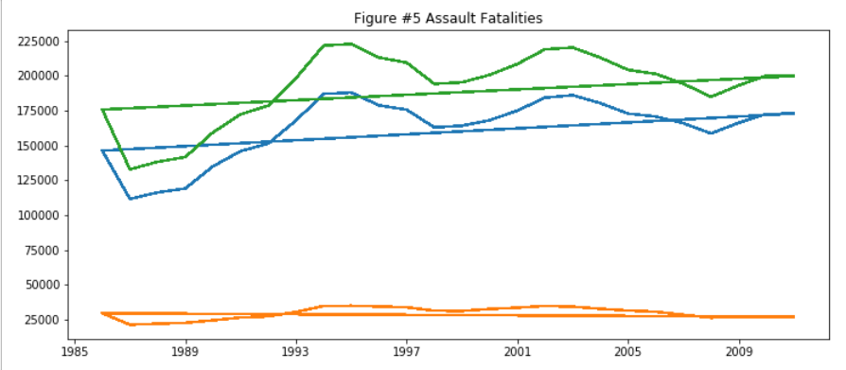

*The final 3 types of unnatural deaths are all on the decline: Suicide, Transportation accidents and Fire incidents.*

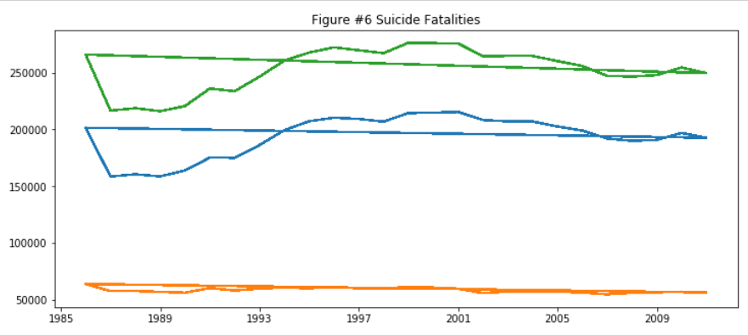

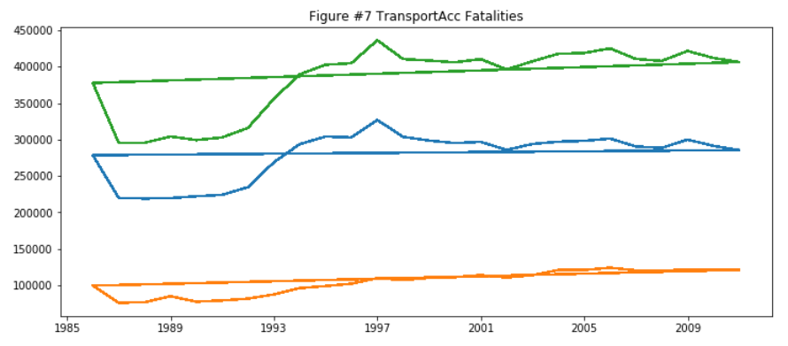

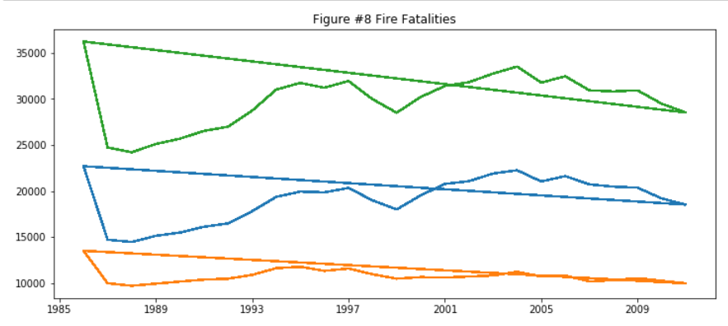

By differentiating the types of deaths, one can illustrate that not all deaths, in relationship to the population growth, are equivalent. They all seem to be trending independently from both the population growth and from one another. In addition, one can provide further insight into the information presented by using supplementary data. For example, one could further classify deaths by country [top 5] as there is 100 data points on country.

There are 2 key countries currently missing from the dataset, China and India. This is due to lack of records for unnatural deaths. In contrast, there was a lot of information on natural deaths, but that is not our focus.

In the following analysis, we will define the top 5 countries by the magnitude of the sum of all death types. We are assuming that countries with larger magnitude in type of death will have more evident data available as to the causes of these deaths. Please note within the next few graphs the colour of the trends represents the top 5 in order:

1. Blue
2. Yellow
3. Green
4. Red
5. Purple

**Transportation Incidents**

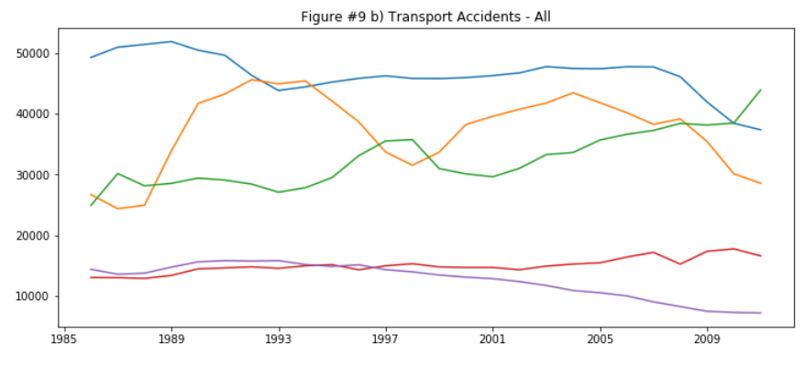

The top 5 countries, by incident count, are the United States (blue), Russia (yellow), Brazil (green), Japan (red) and Mexico (purple).

The international Transportation incidents appear to be on the decline (figure #2) but is this true for all nations. All appear to be on the decline except for Brazil (green line). Brazil’s appears to remain flat and after 2009 starts to increase. I’ve decided to focus on this unique trending as there has to be a story behind it.

Taking a look at the automotive sales trending in Brazil they trend almost exactly the same as the Transportation incidents. The increase in vehicle sales is related directly with Brazil’s GDP growth. We read an anecdotal comment in an article about Brazil stating that the automobile is a symbol of status.

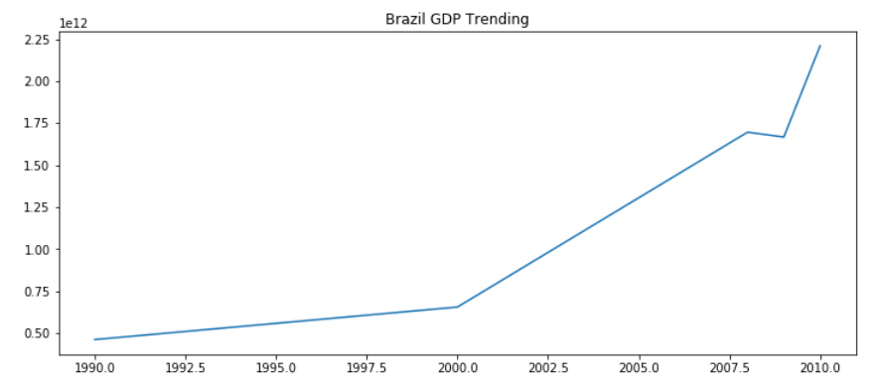

**Death by Assault**

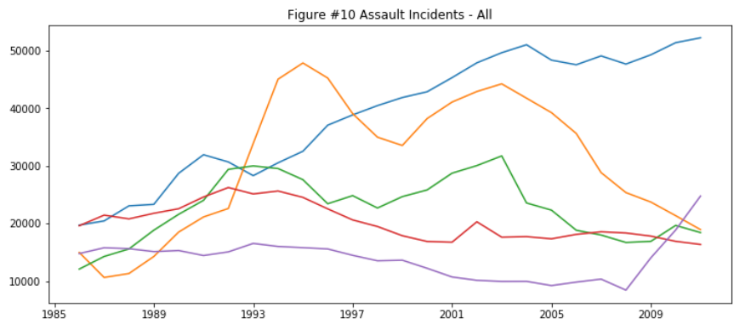

The Top 5 countries for Assault incidents are Brazil (blue), Russia (yellow), Colombia (green), Mexico (red) and the United States (Purple).

Brazil and the United States (blue and purple lines) are both on the rise. I’d like to focus on Brazil and the United States:

Brazil currently ranked as number one by sheer numbers. In 2015, there were more murders in Brazil than the rest of the developed world combined. The following is a Treemap of this statistic:

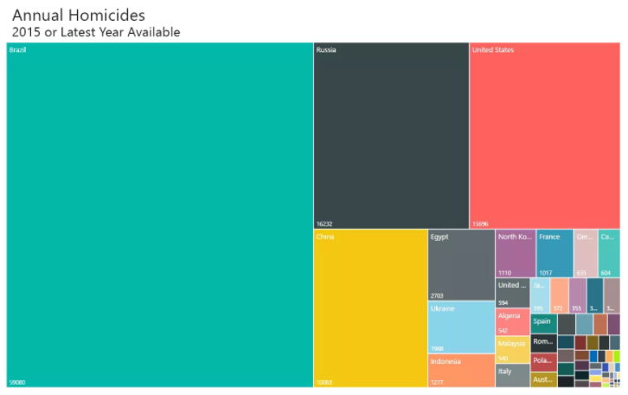

Graph source:<http://metrocosm.com/homicides-brazil-vs-world/>

I’ve found several articles attributing the causes to several different factors, drugs, gangs, the displeasure with government abuse.

Looking into the United States I found the statistics on the murders in the 2016.

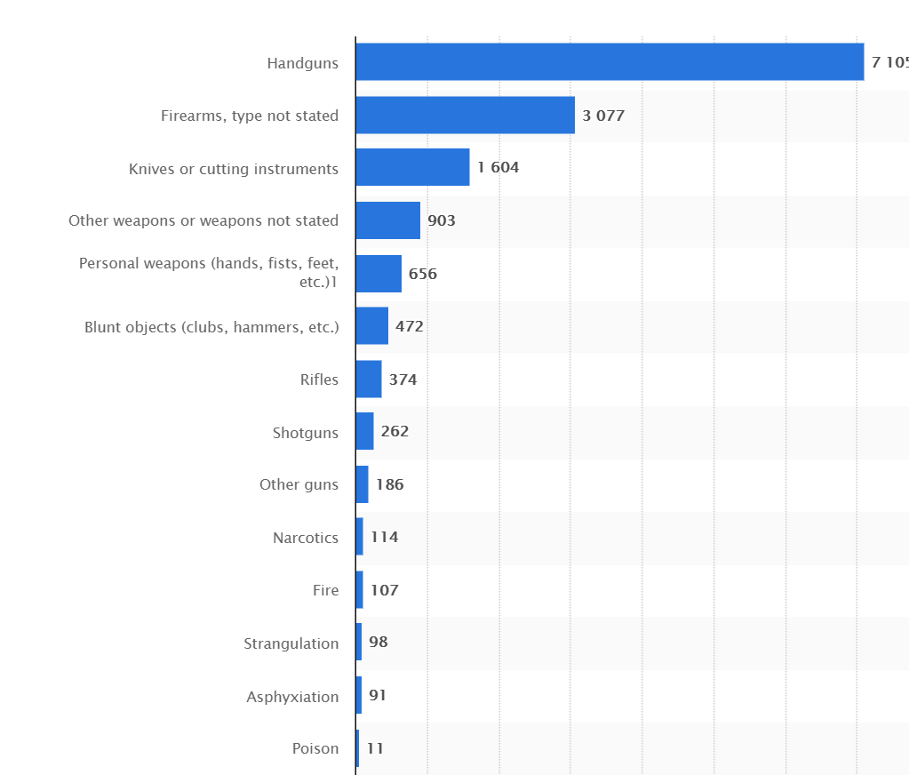

Graph Source: <https://www.statista.com/statistics/195325/murder-victims-in-the-us-by-weapon-used/>

The majority of the 2016 US murders were caused by some sort of firearm. Although there isn’t a clear correlation [based on the trend of gun sales in the United States going back to 1994], one can see there’s a spike in 2009, which corresponds to the data compiled by the World Health Organization [WHO] which demonstrates a spike in murder rates in the U.S. also in 2009.

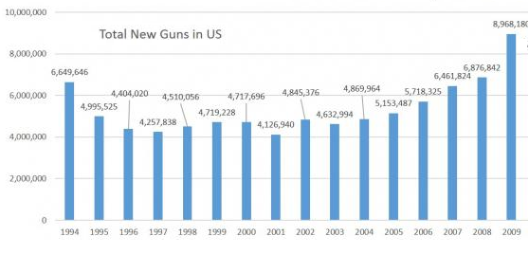

Graph source: <https://www.statista.com/statistics/249740/percentage-of-households-in-the-united-states-owning-a-firearm/>

At this point, this is only a speculation and one would require further data to support this claim. If available, one would require data by each region within the United States, first by State then break it down further by rural versus urban areas and compare the death data against the gun purchase rates.

**Death by Suicide**

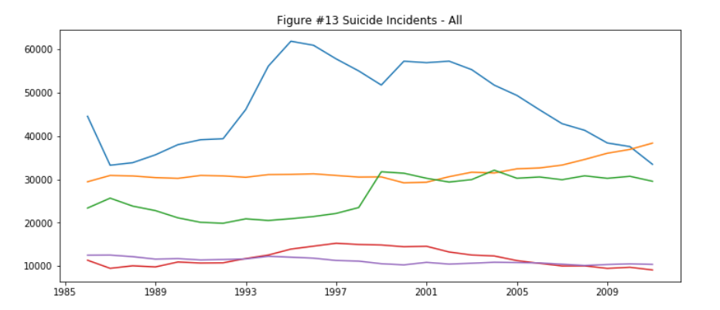

The top 5 countries in suicide counts are Russia, Japan, United States, Japan, Ukraine and France.

Suicide rates are pretty much flat except for the United States (which is on the increase) and Russia (which is on the decline). There’s a spike for Japan (green) in 1998, I was able to find another data source on Japan that trends with the same data spike.

I found Japan’s suicide trending is tied closely to unemployment rates. The unemployment rates in Japan started spiking in the mid 1990’s; at this point, data compiled by WHO begins to spike in 1998 and levels out in 2000 but no longer drops back down. It continues to be an epidemic in the data into 2010’s.

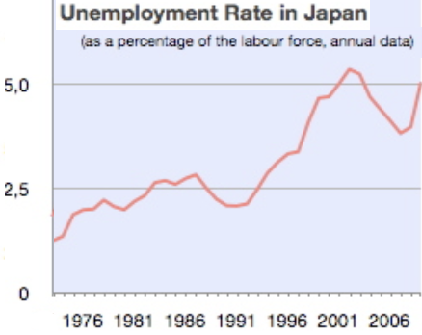

Graph source: <https://commons.wikimedia.org/wiki/File:Unemployment_Rate_of_Japan_1953-2009.jpg>

In the United States, the suicide rates are up in both the baby boomer generation as well as the youth between 15 and 24. The general consensus for older population committing suicide is economic and the difficulty within the job market.

The youth suicide reasons are varied and there is no one or two specific reasons. The data states internet bullying, substance abuse, violence in the media, etc. Thus, I would need to gather more data on these data points to conclusively determine if there is any correlation on any of these reasons.

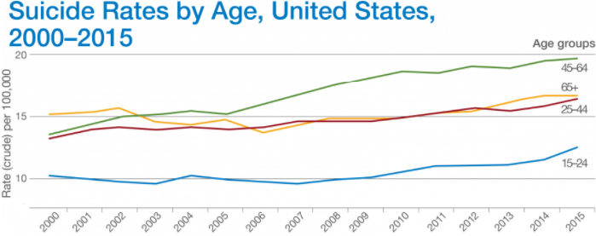

Graph Source: <http://drleonardcoldwell.com/suicide-rates-many-rising-usa/>

**Death by Poison**

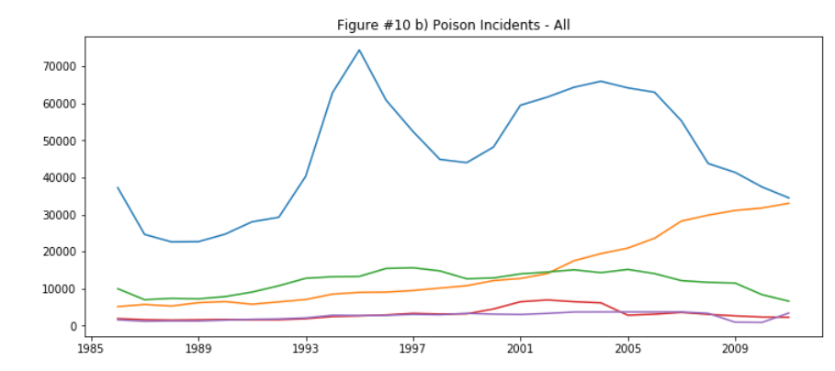

Internationally, death by poison is relatively flat but if we look at the top 5 we get Russia, United States, Ukraine, Kazakhstan and Belarus.

Doing some research on the Russian Federation, it would appear the majority of these poison deaths are due to alcoholism. There is one thing I noted from Russia’s death patterns, they all appear to follow the same general trend. When I looked at historical events in Russia as the graph starts to change direction, I found these major occurrences:

1. 1985 - Mikhail Gorbachev increased controls on alcohol in 1985 (alcohol deaths decrease)
2. 1992 - The fall of the Soviet Union. (alcohol deaths begin to increase)
3. 1998 - Russian financial currency crisis. (alcohol related deaths begin to increase)
4. 2006 - a new alcohol stamp allowing to identify every bottle sold in Russia through a centralized data system (alcohol related deaths drop off)

The United States also appears to be trending upwards in comparison to the international trend and the rest of the top 5 which are all trending downwards. Looking more closely I was able to find that the US has been having problems with substance abuse. If I focus on Opioids, which have been on the news recently, it appears to follow the same trends as the overall poisoning trending.

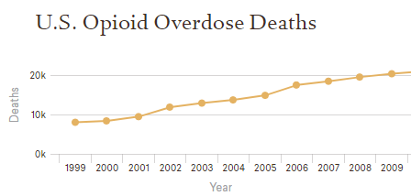

Graph Source: <https://www.cfr.org/backgrounder/us-opioid-epidemic>

**Death by Drowning**

The top countries with the top Drownings by total amount are Russia, Brazil, Japan, Ukraine and USA.

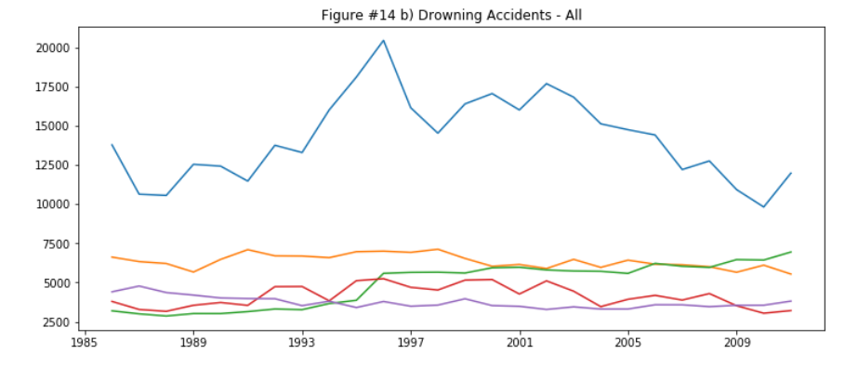

Most drowning incidents within the top 5 countries is trending relatively flat (so reducing based on overall population) except in Russia.

In doing some research it would appear that these deaths are tied to the consumption of alcohol during the activity of swimming. The pattern spikes in the same way as all the other Russian trends but with more “noise”.

There appears to be a second factor affecting the trend, weather. There have been issues with drought which have also caused the Russian populace to increase swimming as a recreational activity.

The following chart is the trending of precipitation levels from 1985 to 2010. 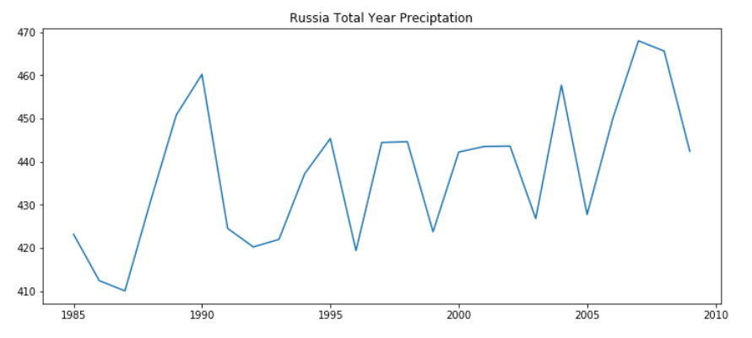

This hypothesis, however, appears to be inconclusive.

**Death by Fire**

Russia, United States, Ukraine, Japan and Brazil

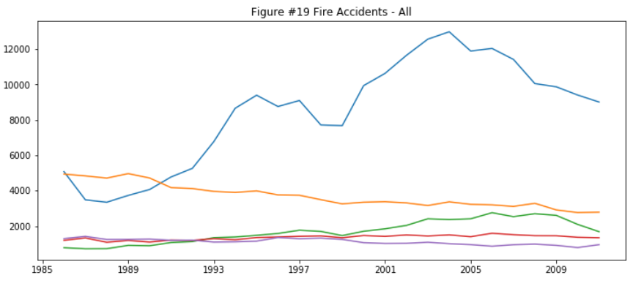

**Quick look at Home**

Taking a look at Canada we can see the way we’re trending. (Blue - All, Orange - Male, Green - Female)

Population: 26 Million 1985 to 34 Million in 2009

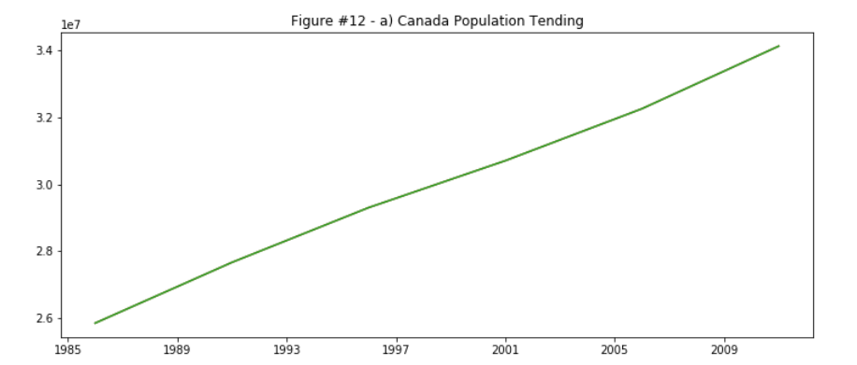

Assault: Trending downwards slightly

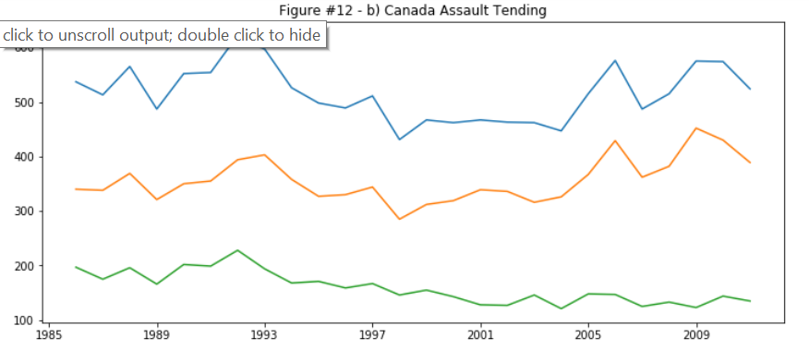

Transportation: Trending downwards steadily

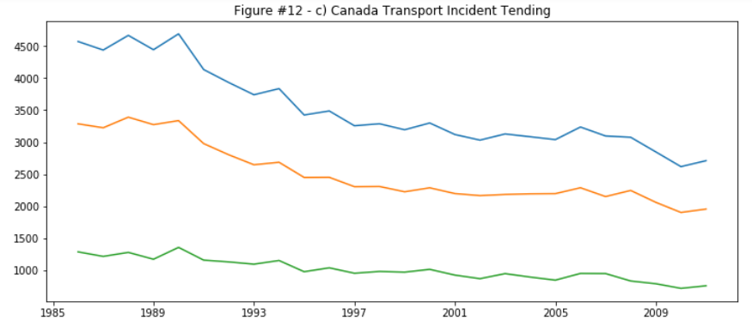

Suicide: Flat with a slight uptick in 2009

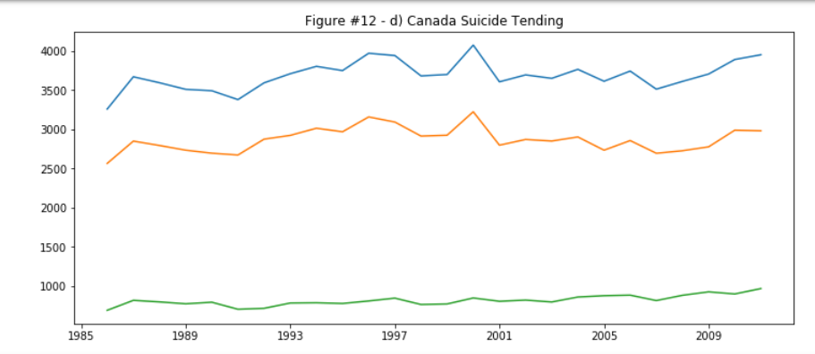

Fire: Trending Downwards

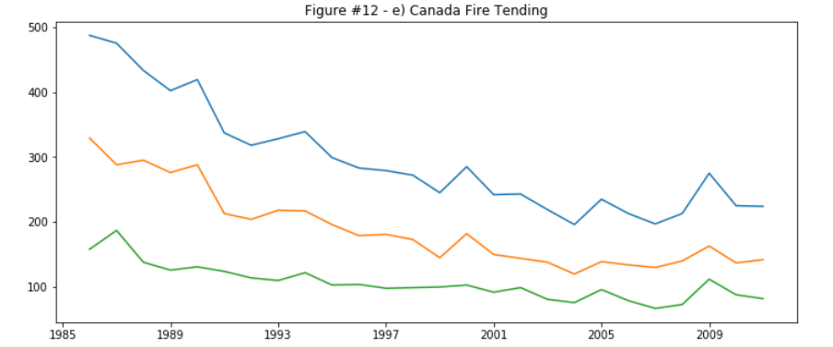

Poison: Trending upwards

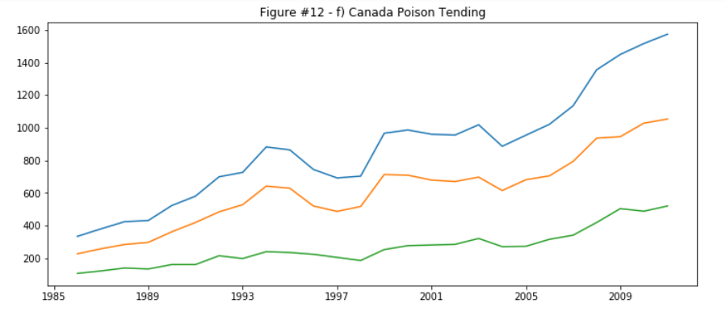

Drowning: Trending Downwards

